### **Step 5. Create Priority-Based Log Files**

1. Command to record all mail log messages, except for debug, to /var/log/mail.log:

Solution:

~$ sudo nano /etc/rsyslog.d/50-default.conf

* + Add the edits made to the configuration file below:

Solution:

mail.!debug -/var/log/mail.log

1. [Your solution edits here]

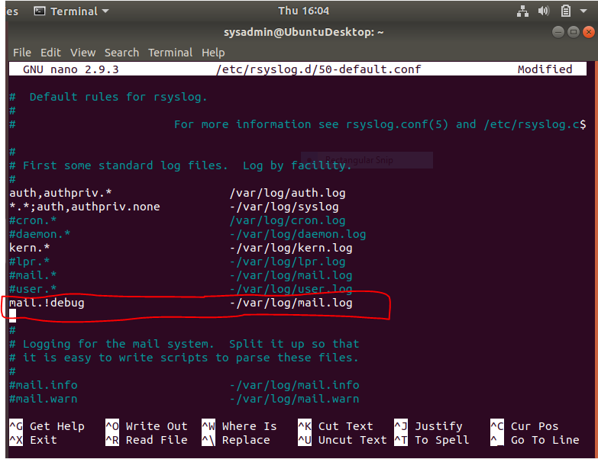

**Bonus**

* Command to record all boot log messages, except for info and debug, to /var/log/boot.log:

Solution:

~$ sudo nano /etc/rsyslog.d/50-default.conf

* + Add the edits made to the configuration file below:

kern.!info,!debug -/var/log/boot.log

* [Your solution edits here]

